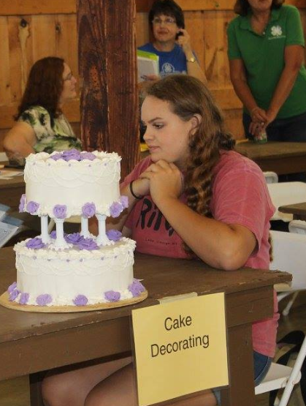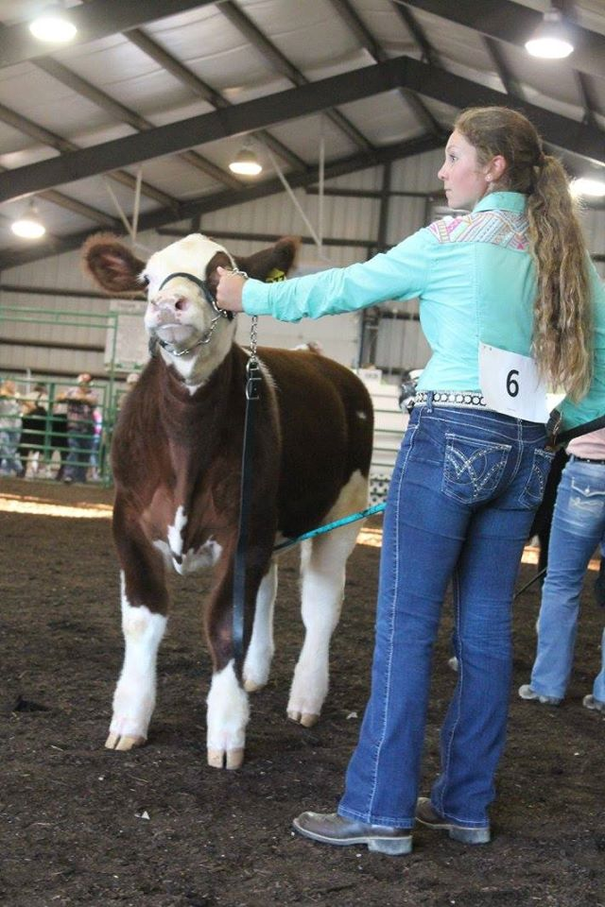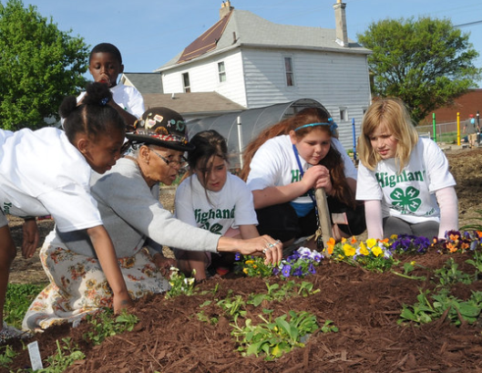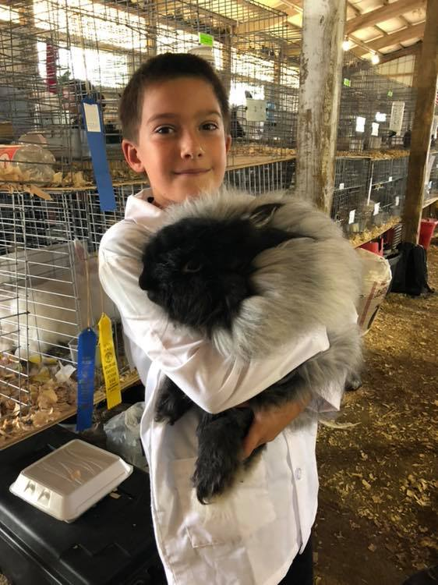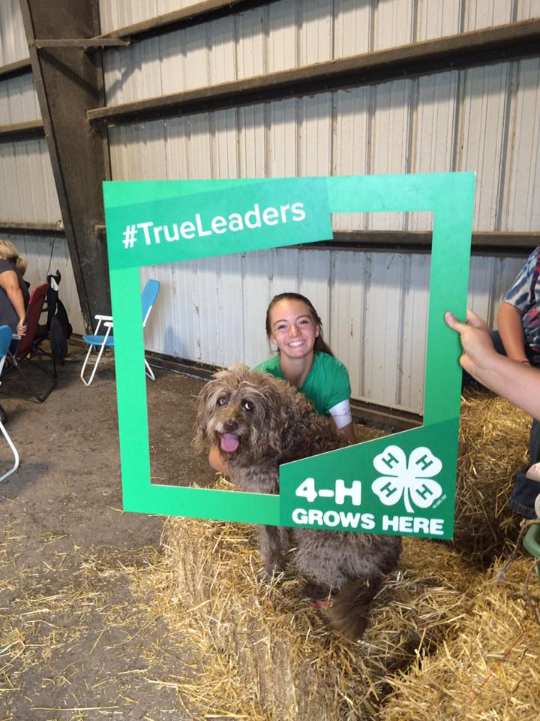

**Have Questions?**

**Visit** [**https://go.osu.edu/joindelco4h**](https://go.osu.edu/joindelco4h)

**Call us at (740)833-2030 or**

**email Cynthia at johnson.8653@osu.edu**

* **Youth age 5 & in kindergarten through 18 years old as of January 1**
* **Participants complete 1+ projects from almost 200 options with the help of background-checked adult club advisors**
* **Project interest areas vary; cooking, sewing, leadership, fishing, rockets, robotics, dogs, horses, woodworking, photography, livestock and more!**
* **In clubs you attend meetings and do service projects**
* **February & March are the best months to enroll – members must be registered before April 15th.**
* **A list of Delaware County 4-H Clubs is on the back. Contact an advisor listed to join the club that’s right for you.**

CFAES provides research and related educational programs to clientele on a nondiscriminatory basis. For more information, visit cfaesdiversity.osu.edu. For an accessible format of this publication, visit cfaes.osu.edu/accessibility

**JOIN DELAWARE COUNTY 4-H!**

**OHIO STATE UNIVERSITY EXTENSION**





**DELAWARE COUNTY 4-H CLUBS**